**Verification Report**

**Report Period:** March 23, 2024 –March 25,2024

**Project Title:** ARA

**Guide:** Dr. D. J. Chaudhari

**Report Prepared By:** Kaustubh Warade

Devansh Parapalli

Aditya Deshmukh

Yashasvi Thool

**Executive Summary:** This report covers the March 23-25, 2024 verification of the ARA web app. Key activities included automating tests for user accounts, response generation, and ML model integration, plus manual testing of responses, authentication, and user experience. Sample prompts confirmed appropriate response generation. Automated tests found no critical errors.

**Current Task Progress:**

|  |  |
| --- | --- |
| Task Description | Verification |
| Scheduled Completion | March 25, 2024 |
| Actual Completion | March 25, 2024 |
| Status | Completed |
| Remarks |  |

**Accomplishments:**

* Automated Verification of
  + Register, Login, Profile and Account Functionality
  + Notebook Response Generation
  + Connection with ML Models
* Human Verification of
  + Response Generation
  + Authentication
  + User Interactivity

**Automated Verification:**

* The model was given prompts automatically and the response generated matched fuzzily to the expected responses.
  + echo “Hello!” :: Hello!
  + What is 3 + 2 ? :: 3 + 2 = 5

**Manual Verification:**

* The accounts and login functionality were verified as working by manual review. The system only accepts the correct email address and password combination as presented during registration.
* Response Generation was verified by submitting prompts. The following items are divided into Prompt :: Response.
  + Explain Bagging and Boosting.  
    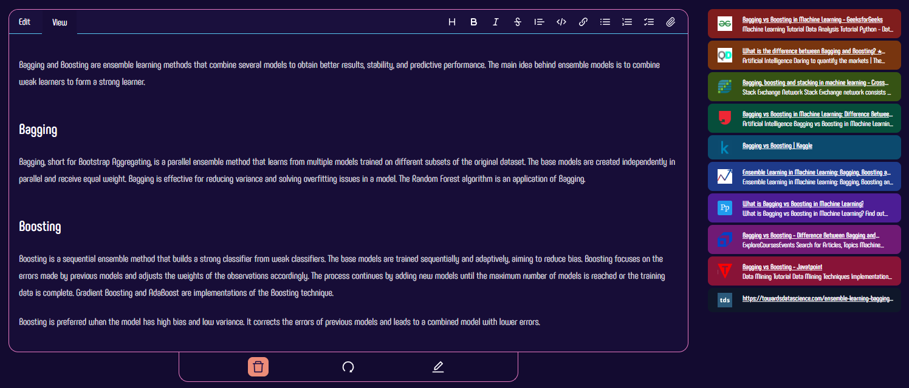
  + Explain Gradient Boosting  
    A screenshot of a computer

    Description automatically generated

The sources given by the model were manually verified to ensure correspondence. These responses indicate that the model and the connection are verifiably correctly working.

* The entire web application was verified as correctly working by automated review, all links are functional and navigate to the intended page, there are no broken links.

**Financial Summary:**

|  |  |
| --- | --- |
| Description | No financial expenditure required |
| Budgeted Amount | Rs. 0 |
| Amount Spent This Week | Rs. 0 |
| Total Expenditure | Rs. 2050 |

**Conclusions and Recommendations:**

In conclusion, the proposed web-based app has undergone rigorous validation testing by manual and automated means. Defects uncovered during the verification process were few and were fixed. All verification criteria were sufficiently met. Based on the verification result, the project can move forward towards deployment.

**Approval:**

Dr. D. J. Chaudhari

Project Guide

Assistant Professor, CSE Department

Government College of Engineering Nagpur

Sector-27, Mihan Rehabilitation Colony

Khapri, Nagpur

441108

Date: April 05, 2024